San Francisco State University School Project

SW Engineering CSC667/867 Spring 2019

eventup

Team 4

Cory Lewis(Team Lead, [clewis9@mail.sfsu.edu](mailto:clewis9@mail.sfsu.edu))

Mitul (GitHub Master)

Chintan Sanjay Puri

Alex Wolski

Vincent

Milestone 2

03/22/19

1. Wire Frames

1.1 Login Screen

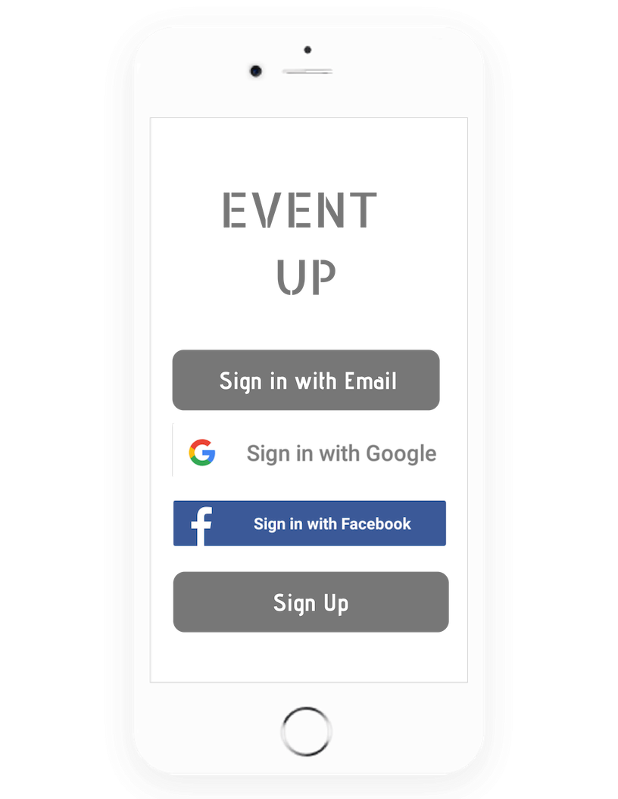

1.2 Sign Up Screen  
 Note: this will be one page which user will scroll

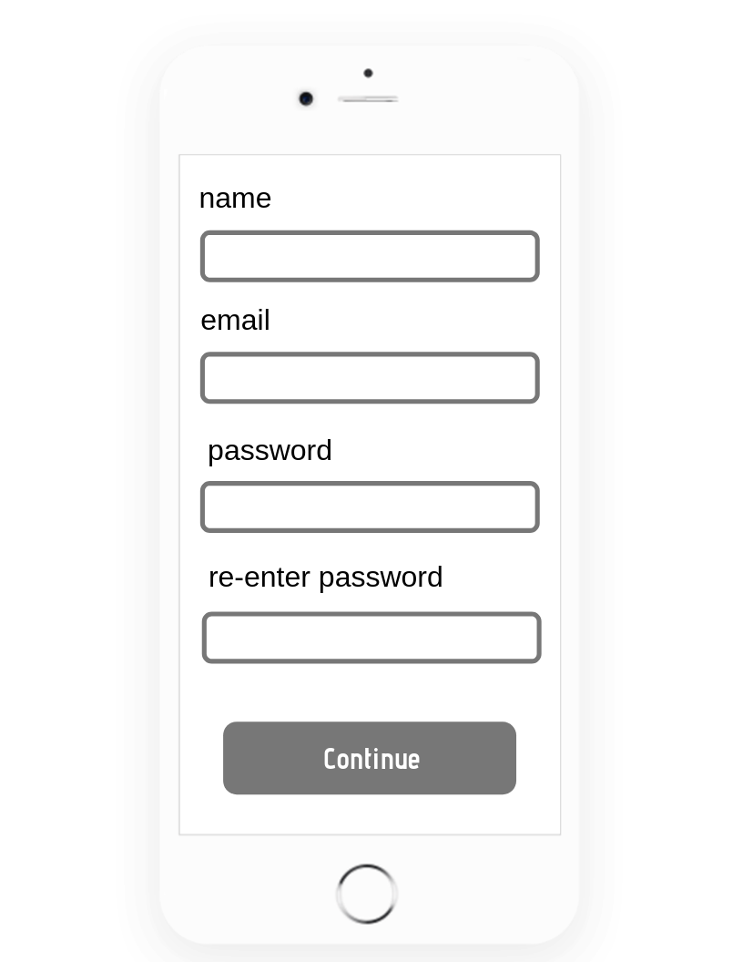

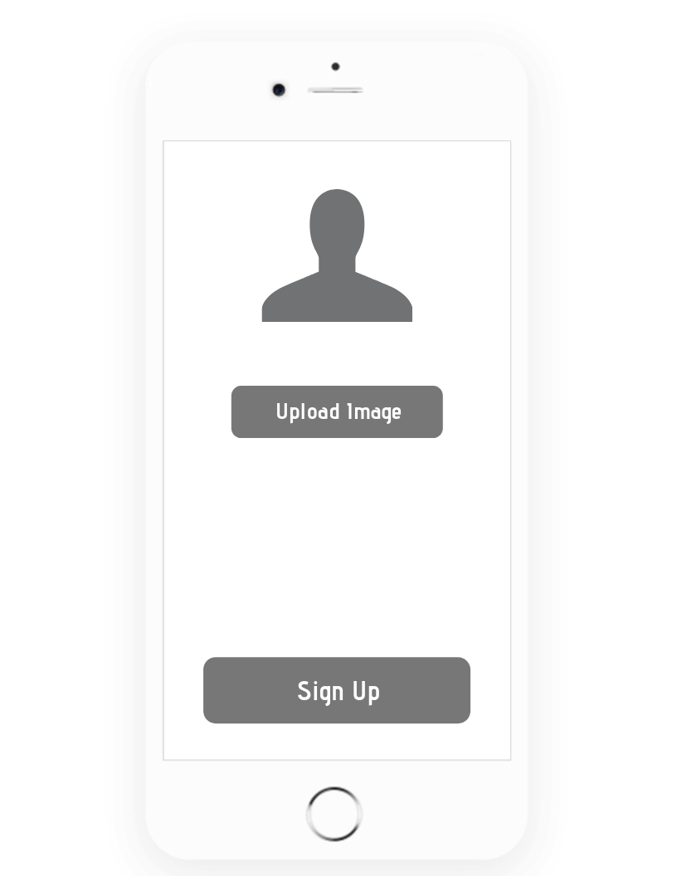

1.3 Events Feed

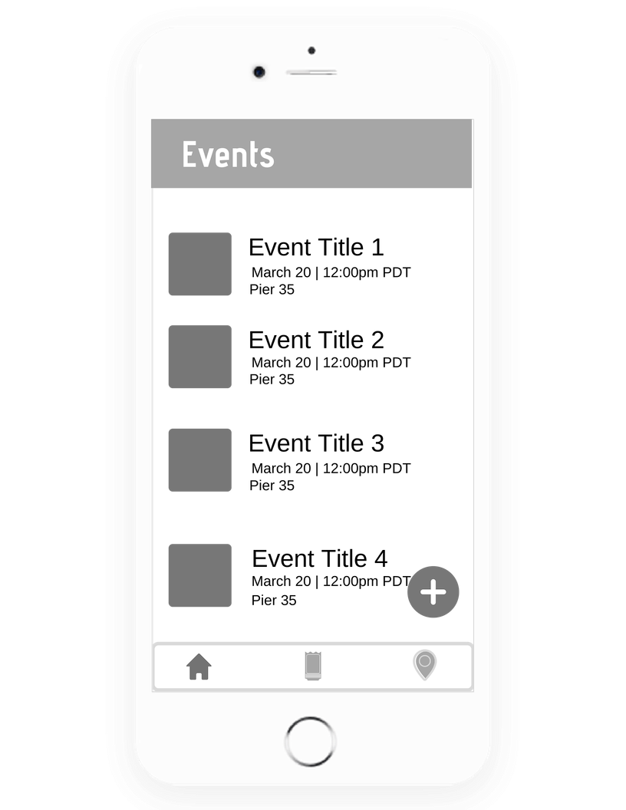

1.4 Users Events

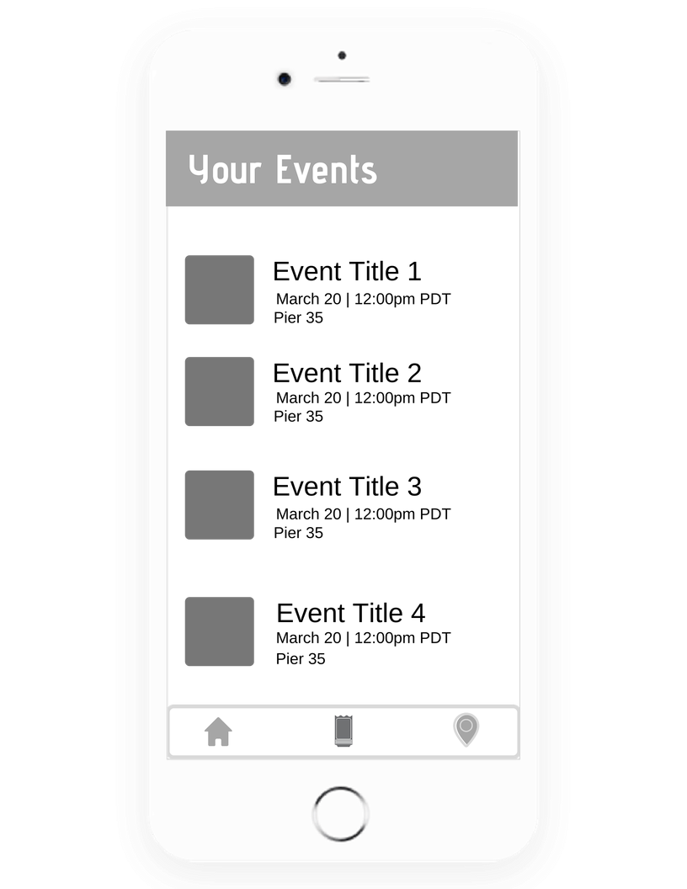

1.5 Sample Event Page

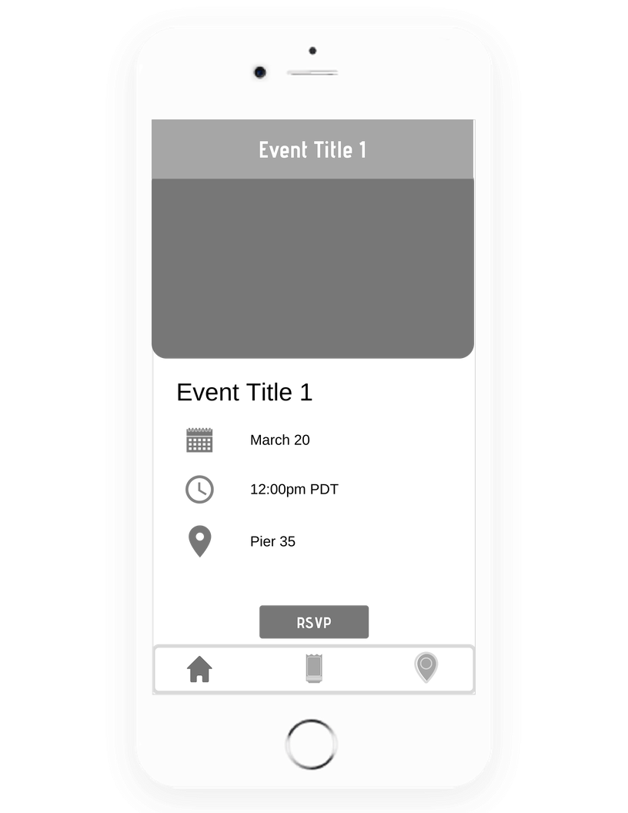

1.6 Events Map

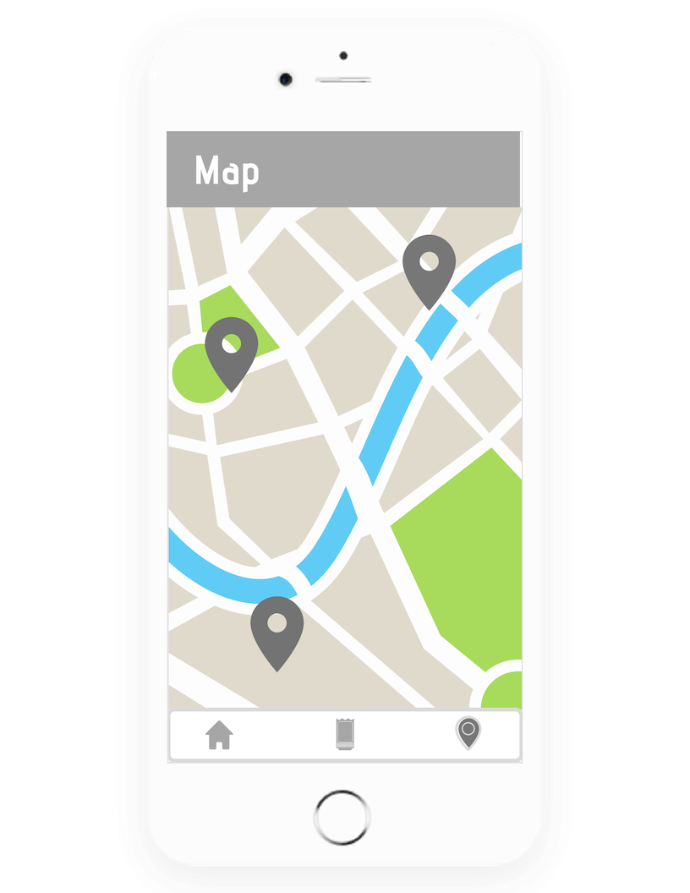

2. Site Map

2.1 Authentication



2.2 Feed



3. Selection and Installation of Software Stack

3.1 Software Stack Specs  
  
 **Server Host**: Amazon Web Services

**Operating System**: Amazon Linux 2 AMI 2.0.201

**Database**: MySQL (v8.0.13)

**Web Server**: AWS EC2, 1 vCPU, 1gb RAM, 8gb SSD

**Server-Side Language**: JavaScript (v1.8.5)

**Web Framework**: Node.js (v10.15.1 LTS)

**Additional Technologies**:

* 1. **IDE**: Visual Studio Code, Sublime, Atom
  2. React Native v0.59
  3. Express.js: v4.16.4
  4. Node.js: v10.15.3
  5. Npm: v6.4.1

3.2 Link to Website running off of software stack

<http://ec2-52-53-164-128.us-west-1.compute.amazonaws.com:8000/>

4. Data Entries (Database Entries and Entities)

|  |  |  |
| --- | --- | --- |
| **Table** | **Purpose** | **Entities** |
| User | User data is held here | id:int, email:string, name:string, image_path:string, password:string |
| Event | All data pertaining to a specific event. Each event has a path to a cover photo. Each event has a type of category. New events will have status of ‘pending’ for admin approval | id:int, name:string, image_path:string, description:string, location:string, category_id:int,  age_restriction:bool,  status:string |
| Category | Labels to describe what category an event falls under | id:int, name:string, type:string |
| Image | Table containing images that pertain to a specific event | id:int, name:string, path:string |
| Message | A user can message a user. | Id:int, sender_id:int, receiver_id:int, content:string, timestamp |
| Favorite | A user can favorite an event | Id:int, user_id:int, event_id:int |
| locations | This is a table of SFSU locations | id: int, name:string, longitude:float, latitude:float |

5 Features that will be implemented

5.1 Unregistered Users

5.1.1 Shall be prompted with a Register/Login screen upon RSVP

5.1.2 Users shall be able to Sign Up with email, Facebook, or Google

5.1.3 Shall have access to view details of events

5.1.4 Shall be able to view event map

5.1.5 Shall be able to view events by category

5.2 Registered Users (can perform all tasks of Unregistered user)

5.2.1 Shall be able to RSVP for events

5.2.2 Shall be able to contact hosts of events

5.2.3 Shall be able to edit their own profile

5.2.4 Shall be able to host events (approved by admin)

5.2.5 Shall have the ability to view all portions of the app

5.2.6 Shall have the ability to view event history that they previously attended

5.2.7 Shall be able to favorite events

5.3 Admin

5.3.1 Shall have the ability to accept pending events

5.3.2 Shall have the ability to block events

5.3.3 Shall be able to block registered user

5.4 Event Feed

5.4.1 Users will see a timeline of events

5.4.2 Tapping on these events will bring up the respective event page with optional media and details describing the event

5.5 Event Map

5.5.1 Users will be able to see a map with events around them (This includes SFSU verified events and events posted by registered users)

5.6 Navigation Menu Toggle

5.6.1 Users shall have the ability to view a navigation menu that gives them access to many features within the app itself

5.6.2 Some accessible tabs would be: Event Feed, Event Map, and WIFI Map

5.7 WIFI MAP

5.7.1 Wi-Fi Signal strength feature that displays a Wi-Fi signal map of SFSU to students

5.7.2 Collect user data about Wi-Fi strength and report it to the database for record keeping

5.7.3 Users can mark areas on the Wi-Fi map (pin drop) that they can use for future reference

5.8 Rest API

5.8.1 Create a rest API that connects the Node.js back end to the React Native front end